 | 10.1.15 Editors - Compositor Editor - Header - Add Menu - Matte
Table of content
Detailed table of content 1
Add menu - Tracking 3
Plane Track Deform 3
Stabilize 2D 4
Track Position 5

Detailed table of content
Detailed table of content
Detailed table of content 1
Add menu - Tracking 3
Plane Track Deform 3
Inputs 3
Image 3
Properties 3
Movie Clip 3
Object 3
Plane Track 3
Motion Blur subpanel 3
Samples 3
Shutter 3
Outputs 4
Image 4
Plane 4
Stabilize 2D 4
Inputs 4
Image 4
Invert 4
Properties 4
Movie Clip 4
Clip browser 4
Name 4
Number of users 4
Fake User 4
Open Clip 4
Remove Clip 5
Sampling subpanel 5
Interpolation 5
Extension X 5
Extension Y 5
Outputs 5
Image 5
Track Position 5
Properties 5
Movie Clip browser 5
Open 5
Name 5
Fake User 6
Load File 6
Delete File 6
Tracking Object 6
Track Name 6
Mode 6
Absolute 6
Relative Start 6
Relative Frame 6
Absolute Frame 6
Outputs 6
X/Y 6
Speed 6

Add menu - Tracking
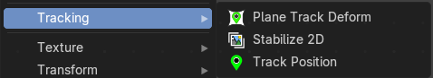
The Tracking menu contains nodes for tracking motion data.

Plane Track Deform
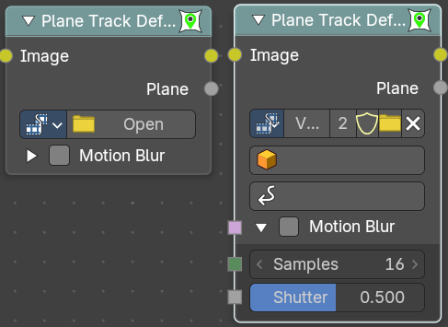
The Plane Track Deform Node is used to incorporate the special “plane track” in your composite by checking areas which are planes, and replacing their footage with some other image.
Before using this node, plane track for the footage should be made in the Movie Clip Editor.

Inputs

Image
Image to put in place of the plane track, and thus, override that area in the movie clip.

Properties

Movie Clip
Used to select the movie clip whose plane track to use. For controls see Data-Block Menu.

Object
Used to select the object to which the plane track is linked.

Plane Track
Used to select the plane track to use.

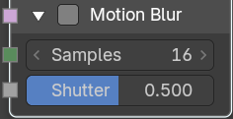
Motion Blur subpanel
Specify whether to use blur caused by motion of the plane track or not.

Samples
Motion Blur setting. Set the number of samples to take for each frame. The higher this number, the smoother the blur effect, but the longer the render, as each virtual intermediate frame has to be rendered.
Note. Samples are taken only from the next frame, not the previous one. Therefore the blurred object will appear to be slightly ahead of how it would look without motion blur.

Shutter
Motion Blur setting. Time (in frames) the shutter is open. If you are rendering at 24 fps, and the Shutter is set to 0.5, the time in between frames is 41.67 ms, so the shutter is open for half that, 20.83 ms.

Outputs

Image
The output by perspective wrapping the image to that plane track.

Plane
Produces a black-and-white mask of the plane track.

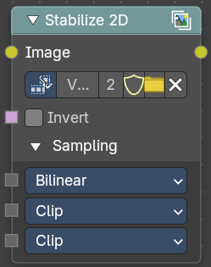
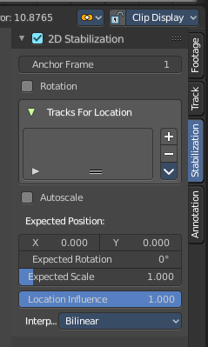
Stabilize 2D
The Stabilize 2D node stabilizes the footage according to the settings set in Movie Clip Editor in the Sidebar in the Stabilization tab in the 2D Stabilization panel. For more information, see the chapter there.

Inputs

Image
Standard image input.

Invert
Invert the stabilization. If the stabilization calculated is to move the movie clip up by 5 units, this will move the movie clip down by 5 units.

Properties

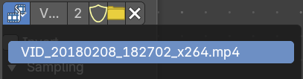
Movie Clip
The movie clip whose stabilization to use.

Clip browser
The available loaded clips

Name
The name of the active clip.

Number of users
How much users this clip has.

Fake User
Keep it in the scene even if it has no users.

Open Clip
Open a new clip.

Remove Clip
Remove the active clip. The clip will remain in the scene, and will be removed when you close Bforartists and it has no user anymore. See Fake User.

Sampling subpanel

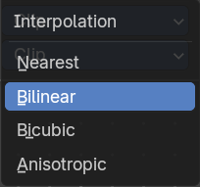
Interpolation
Filter methods for the stabilization.

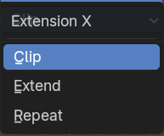
Extension X
How to extend the image in x direction.

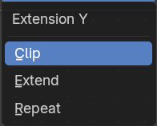
Extension Y
How to extend the image in x direction.

Outputs

Image
Standard image input.

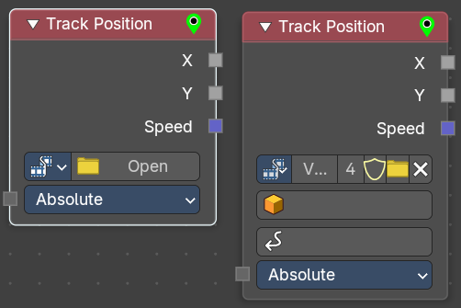
Track Position

The Track Position node is used to return information about a tracking marker to the Compositor. You need a tracking project here.

Properties

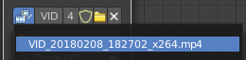
Movie Clip browser
Choose a loaded movie file.

Open
Open a movie file.

Name
Read and edit the name of the video.

Fake User
Assign a fake user to this video. Fake users is an odd concept to keep data in the scene even if it has no user somewhere. The fake user is then a dummy user so that the object is not deleted when saving the scene.

Load File
Load a new video.

Delete File
Delete this video.

Tracking Object
Camera object to get track information from.

Track Name
The name of the track to get track information from.

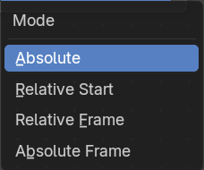
Mode
Which marker position to use for output.

Absolute
Outputs an absolute position of a marker.

Relative Start
Outputs the positions of a marker relative to the first marker of a track.

Relative Frame
Outputs the positions of a marker relative to the markers of the given Frame.

Absolute Frame
Outputs the absolute positions of a marker at the given Frame.

Outputs

X/Y
The marker’s X and Y location.

Speed
The velocity of the marker, measured in pixels per frame. This could be used to fake effects like motion blur by connecting it to the Vector Blur Node.

